Open Microsoft Publisher, Blank Pages, Portrait 8.5 x 11

Save the document: Save as Publisher, Choose Desktop, and then 5R First Name Last Name

Make sure View/Tool bars/Objects is check marked so that it appears on the far left side of the document

1. Bottom Rectangle

* On the objects toolbar: Choose rectangle tool
* Click & drag on Bottom half of paper, no line & fill effects 2 colors
* Gray & white with white on top and gray on bottom on horizontal

2. Top Rectangle

* On the objects toolbar: Choose rectangle tool
* Click & drag on Top half of paper, no line & fill effects 2 colors
* 2 blues with lighter blue on bottom on horizontal
* With this rectangle selected, hold the shift key and select the other one, then group both rectangles together

3. Snowman’s bottom circle

* On the objects toolbar: Choose oval tool
* Hold down the shift key & go to the gray work space on the left side of the paper
* Click & drag to make the bottom circle, when it’s the right sized, let go of the shift key
* Size circle from a corner (not the middle grab bars) (make sure to hold down the shift key until you let go of the mouse’s click button)
* ~~Leave line black & fill with white~~ wait until all 3 body parts are made & grouped together, then fill with white
* ~~With the circle selected, use arrow keys to place the circle where needed~~

4. Snowman’s middle circle

* With the bottom circle selected use the copy icon to copy, then the paste icon to make the 2nd circle.
* Use the up arrow key to move this circle above the bottom circle
* ~~Hold down the ctrl button & click and drag upward~~
* ~~When above the bottom one, let go of the click button on the mouse~~
* ~~Then let go of the ctrl button (same as right click copy, right click paste~~)
* Size circle from a corner (not the middle grab bars) (make sure to hold down the shift key until you let go of the mouse’s click button)
* With the circle selected, use arrow keys to place the circle where needed, touching the bottom circle

5. Snowman’s face

* On the objects toolbar: Choose the Auto shape, the Basic shape, then the smiley face
* Click & drag to make the smiley face (make sure to hold down the shift key until you let go of the mouse’s click button)
* Size face from a corner (not the middle grab bars)
* With the face selected, use arrow keys to place the face where needed

6. Align 3 body parts

* While holding down the shift key
* Use the mouse to click on each of the 3 body parts to select them (make sure background is not selected)
* Then go the toolbar & choose **Arrange** drop down menu to **Align** **& Distribute**, choose **Align Center**
* Then group all three circles together
* Then go to the gray work area around the paper & click so that nothing is selected

7. Hat

* 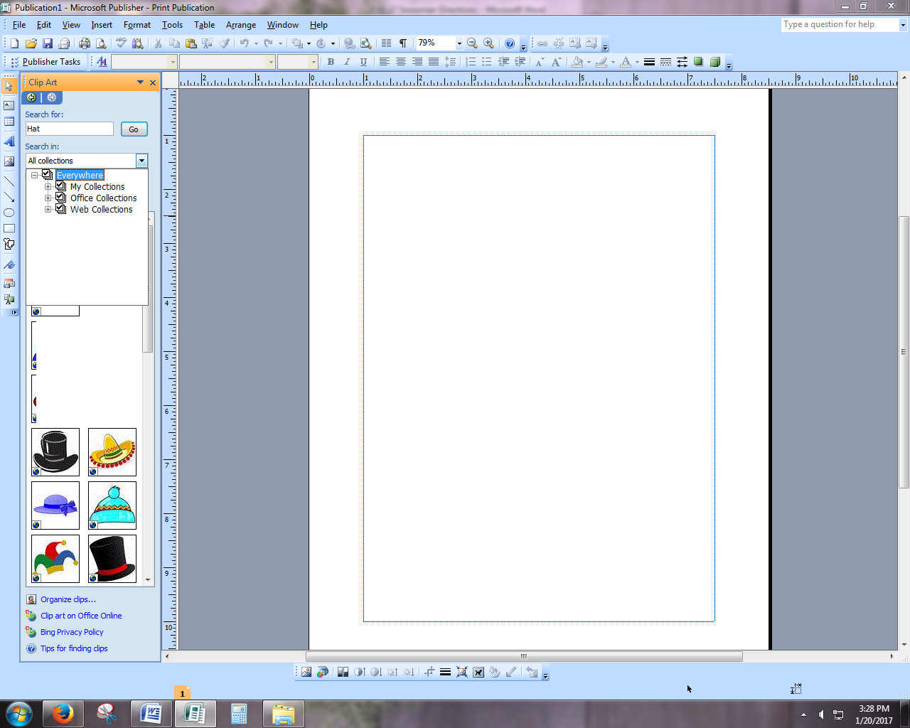Go to the top tool bar & choose: **Insert** – **Picture** – **Clip Art**
* A tool bar will open on the left
* Under Search For: type in **hat if only 2 choices of hats appear in left toolbar, go to Search in & make sure everywhere is selected. Then refresh hat search**
* Look through pictures with the scroll bar, choose a hat that has **no background. They can choose a few different ones and put them in the gray work space.**
* Size hat by the corner to fit the face
* If needed the hat can be tilted with the green rotation button or flipped horizontally with button on tool bar
* When hat is correct select it & hold shift to also select snowman & group all of these together

8. Twig/Arms

* On the clip art tool bar
* Search For: either **twig, branch, or arm**
* Look through pictures with the scroll bar, choose a picture to use for the snowman’s arms that has no background
* Size ***arm*** by the corner to fit the size of the snowman, may also have to make it more narrow
* Place it on the left side of the snowman
* If needed the arm can be tilted with the green rotation button and/or flipped vertically with the Rotate button on tool bar
* Once the size is correct & the arm is selected, hold down the ctrl key & click and drag the picture to the right
* After the 2nd arm is on the right side, let go of the mouse’s click button, then let go of the ctrl key
* With only the 2nd arm selected, go to the **Rotate** button on the top toolbar & choose **Flip Horizontal**
* Use the arrow keys to move the right arm into place
* When both arms are in place hold shift to select both arms & rest of snowman & group all of these together

9. Scarf/Ribbon

* On the clip art tool bar
* Search For: either **scarf or ribbon**
* Repeat the same steps for #8
* When both sides of the scarf are in place hold shift to select both sides & rest of snowman & group all of these together

10. Nose

* Close the clip art tool bar
* Use the Objects tool bar on the left
* Choose Auto Shapes, Basic Shapes, Isosceles Triangle
* Drag by a corner to size
* With the triangle selected go to the **Fill bucket button** on the top tool bar & choose orange
* Then choose the **Line Button** on the top tool bar & choose the same color of orange
* If needed the nose can be tilted with the green rotation button or flipped horizontally with button on tool bar
* May need to also select **Order Button** & choose **Bring to Front**
* When the nose is in place hold shift to select it & rest of snowman & group all of these together

11. Select the snowman & move it on the page for best placement, using the arrow keys

12. Once in place, press Ctrl + A together to select all & once again group

