

By
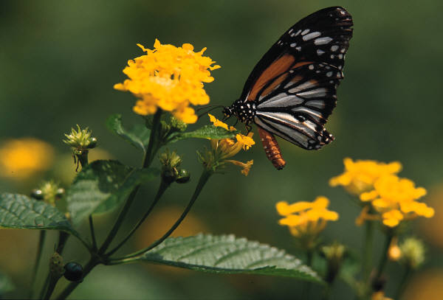

Name
Jefferson School
4th Grade - Phelps
2008-2009
My Poetry Collection
Table of Contents
Acrostic Poem 3
Alphabet Alliteration 4
Cinquain 5
Color Poem 6
Concrete Poem 7
Creature Alliteration 8
Five Senses 9
Haiku 10
Who-What-When-Where-Why 11
Other Poems I Wrote 12
Poems I Like by Other Writers 13
Self-Reflection & Critiques Sheet 14
Grading Sheet 15
Acrostic Poem
C
A
P
I
T
A
L
Alphabet Alliteration Poem
A
B
C
D
E
F
G
H
I
J
K
L
M
N
O
P
Q
R
S
T
U
V
W
X
Y
Z
Cinquain Poem
One
Two
Three
Four
One
Color Poem
is
is
is
is
smells like
tastes like
sounds like
looks like
feels like
makes me
is
Concrete Poem

I am full of information, I love to be read, but don’t tear me or fold out my pages!

Creature Alliteration Poem

Five Senses Poem

Haiku Poem

Who-What-When- Where-Why Poem
(W-W-W-W-W Poem)
“Title”
Who:
What:
When:
Where:
Why:

Other Poems I Wrote

Poems I like by Other Writers

Self-Reflection and Critiques
Write a few thoughts explaining your feelings about writing poetry. Which poems did you enjoy most? Did your feelings about poetry change as you completed this unit?
Self-Reflection

Now share your poetry book with several important adults in your life (parents, relatives, previous teachers, family friends, etc). Ask these people to write a few comments about your creativity and efforts then have them sign their name.

Grading Sheet:
Type of Poem | Comment | Score
Acrostic Poem
Alphabet Alliteration
Cinquain
Color Poem
Concrete Poem
Creature Alliteration
Five Senses
Haiku
Who-What-When-Where-Why
Other Poems I Wrote
Poems I Like by Other Writers
Self-Reflection & Critiques Sheet

